# Technical Design Document: Programming_Exercise_7

# Name: Christian Innes
# Date: October 25th, 2026
# Program Description: Checks amount of paragraphs and sentences provided and returns with the total number of paragraphs

##Function:
Takes the paragraphs and sentences provided. Counts the amount given for each category. Returns with total amount of paragraphs
##Parameters:
Paragraph – Inputs the paragraph
lower – makes everything lowercase so can check easier
Strip – removes extra spaces.
Findall – returns the pattern and paragraph
Print – returns with total sentences
Enumerate – numbers out the sentences
Lens – Retuns items listed
##Variables:
Pattern – Stored data used to identify sentences
Count – Used to track number of paragraphs
Paragraph – Stores the paragraphs inputted
Sentences – Stores all the sentences from the paragraph
Sentence – Stores the sentence
Number – Gives number for each sentence
##Logic:
Asks for sentences/Paragraphs
Counts Amount of sentences
Gives total amount of paragraphs
##Return:
Returns with the number of paragraphs and sentences.
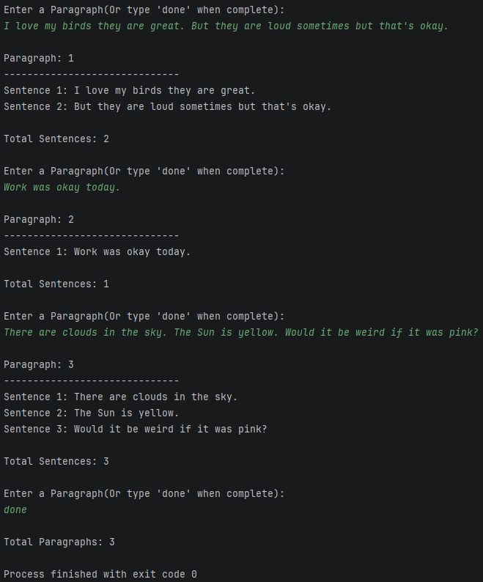
#Link to your repository: https://github.com/monky6676/COP2373

